**Assignment -1**

Flask Programming

|  |  |
| --- | --- |
| Assignment Date | 14 September 2022 |
| Student Name | Mr. G.SAMSON |
| Student Roll Number | 814619106301 |
| Maximum Marks | 2 Marks |

**Question-1: Create 5 tables in IBM db2 and insert data by using insert query**

**Solution:**

CREATE TABLE inventory (

id INTEGER PRIMARY KEY,

item TEXT,

price REAL);

INSERT INTO inventory VALUES (1, "banana", 20.00);

INSERT INTO inventory VALUES (2, "grapes", 5.00);

INSERT INTO inventory VALUES (3, "water lemon", 10.00);

INSERT INTO inventory VALUES (4, "orange", 30.00);

INSERT INTO inventory VALUES (5, "apple", 30.00);

SELECT * FROM inventory;

**OUTPUT:**

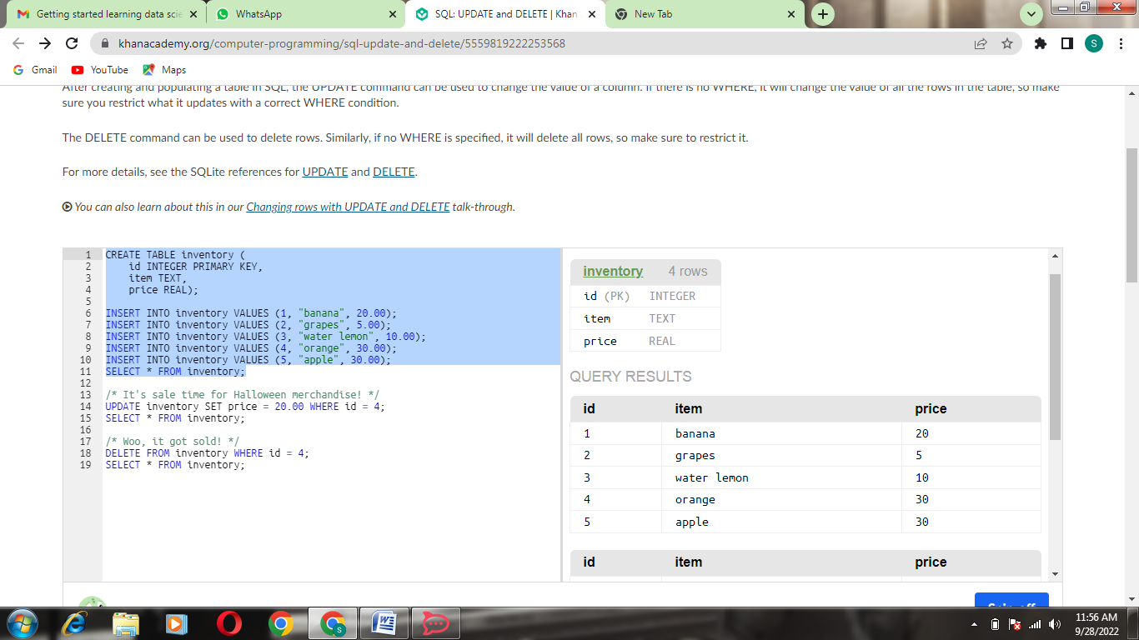

**Question-2: Perform UPDATE, DELETE Queries in 5 tables.**

**Solution:**

CREATE TABLE inventory (

id INTEGER PRIMARY KEY,

item TEXT,

price REAL);

INSERT INTO inventory VALUES (1, "banana", 20.00);

INSERT INTO inventory VALUES (2, "grapes", 5.00);

INSERT INTO inventory VALUES (3, "water lemon", 10.00);

INSERT INTO inventory VALUES (4, "orange", 30.00);

INSERT INTO inventory VALUES (5, "apple", 30.00);

SELECT * FROM inventory;

/* It's sale time for Halloween merchandise! */

UPDATE inventory SET price = 20.00 WHERE id = 4;

SELECT * FROM inventory;

/* Woo, it got sold! */

DELETE FROM inventory WHERE id = 4;

SELECT * FROM inventory;

**OUTPUT:**

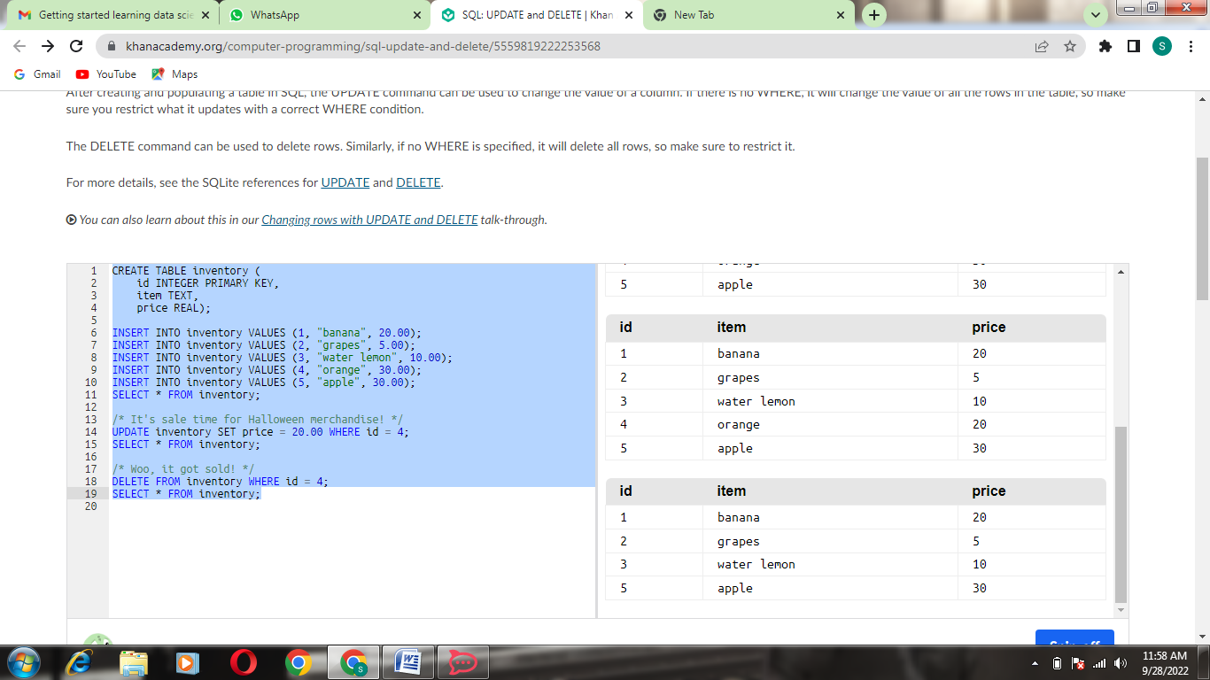

**Question-3: Load excel comma separated file to db2?.**

**Solution:**

Excel

Open –file

(String) [--passwordtopen--]

(String)] [--passwordtomodify--]

(String)] [--usetemplate(Boolean)] –Template

(String) [--savechanges(Boolean)]

[--notcalculate(Boolean)]

(Boolean)=success

(String)=reason

(Excel)=value

**OUTPUT:**

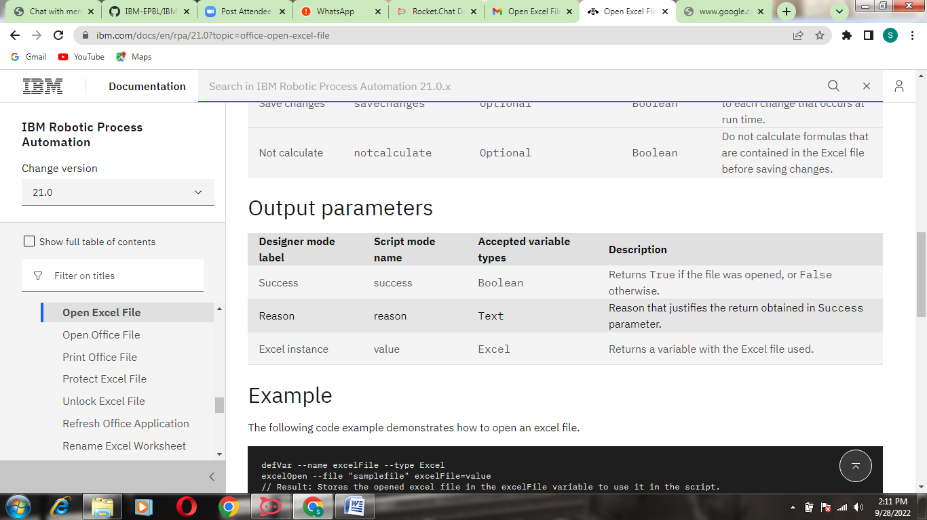

**Question-4: Connect python to db2.**

**Solution:**

Import pyodbc

import os

pw = os.environ.get("DB2PW")

user = os.environ.get("DB2USER")

con =pyodbc.connect("DSN=testpython; UID="+user+"; PWD="+pw)

print("connected")

cur = con.cursor()

cur.execute("SELECT PROD_NAME from prod")

data =cur.fetcha11()

print(data)

**OUTPUT:**

